**AWS Task-1**

**Task Description:**

Create a windows Vm machine in AWS and connect with RDP open CMD in windows share the about system info.

**Lunched EC2 Instance:**

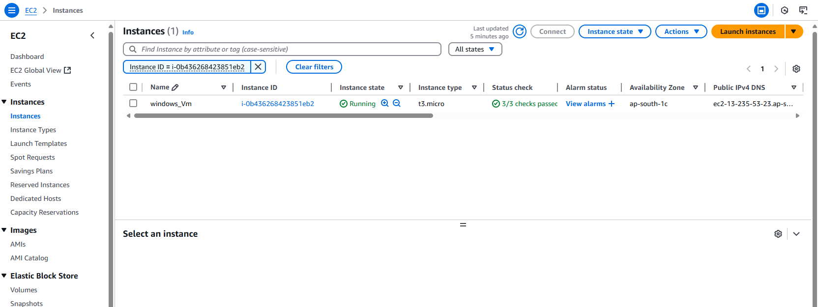  
  
  
**Windows VM RDP Access and System Info Details:** 